**Assignment 1: Create a web server and an Amazon RDS DB instance**

1. **Launch an EC2 Instance**

* In your AWS account create an EC2 Instance, choose Launch Instance

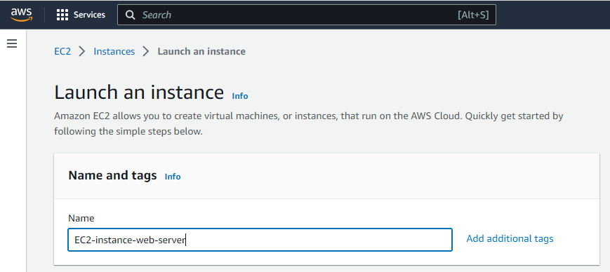

* Create a new Instance under Amazon Linux
* Chose a Key pair
* Allow SSH Traffic from, choose MY IP
* Allow HTTPs traffic from the internet
* Allow HTTPs traffic from the internet

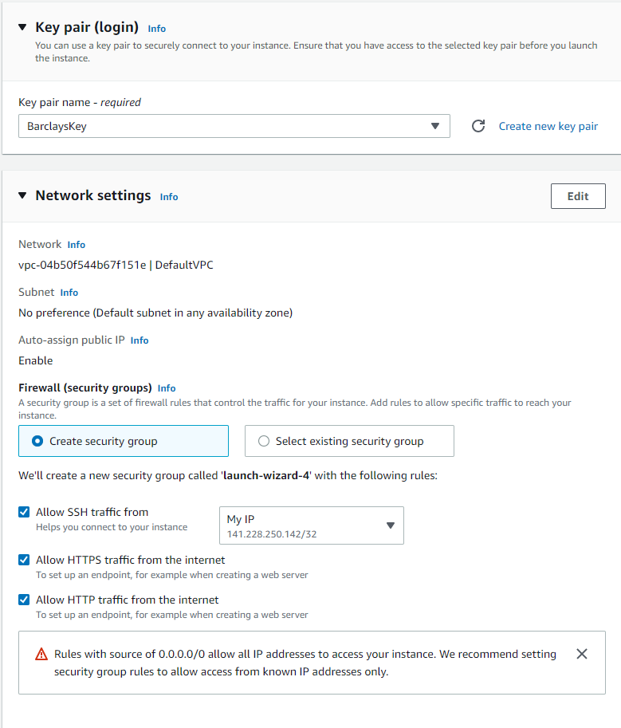

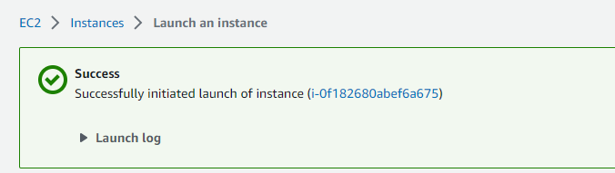

1. **Create an DB Instance**

* Choose RDS from the services
* Create a new database
* Choose My SQL

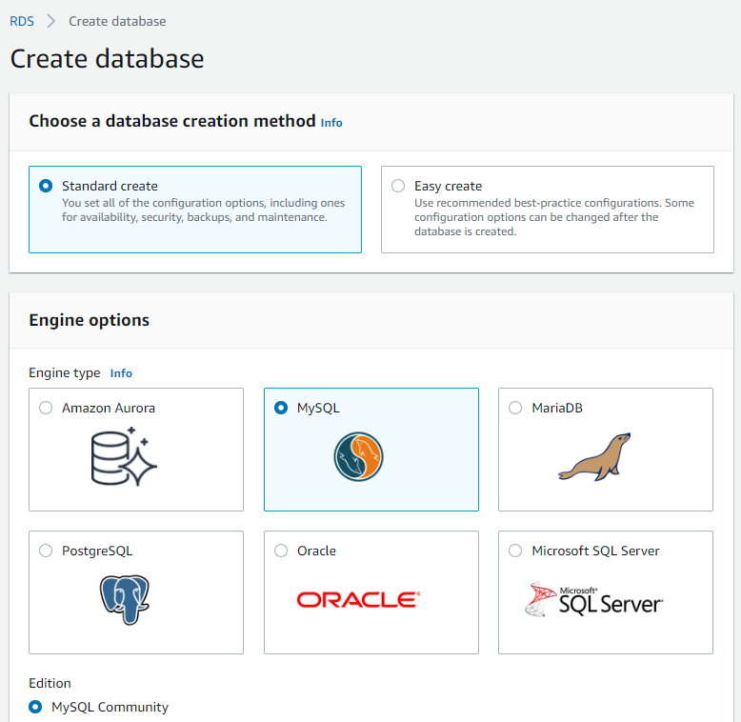

* Give a name for database identifier
* Username and set a password

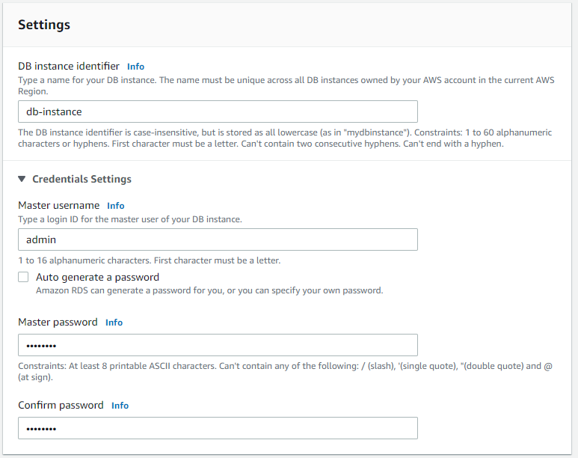

* In Connectivity, choose to connect to a EC2 compute resource

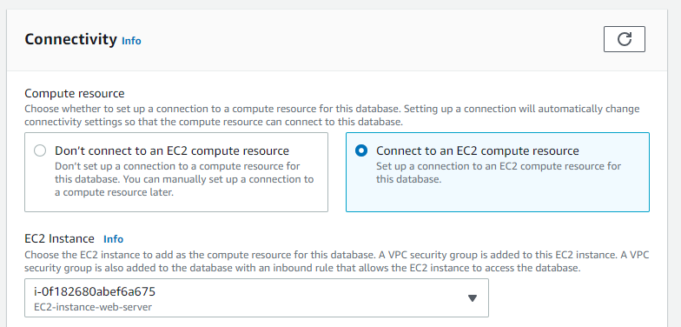

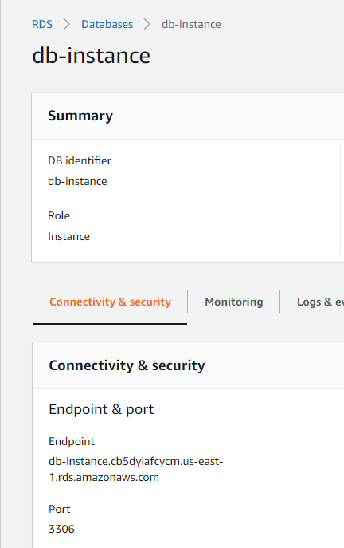

1. **Install a web server on your EC2 Instance**

* Connect to the EC2 instance that you created earlier by following the steps in Connect to your Linux instance.
* Get the latest bug fixes and security updates by updating the software on your EC2 instance. To do this, use the following command.

sudo yum update -y

* After the updates complete, install the PHP software using the amazon-linux-extras install command. This command installs multiple software packages and related dependencies at the same time.

sudo amazon-linux-extras install php8.0 mariadb10.5

* Install the Apache web server.

sudo yum install -y httpd

* Start the web server with the command shown following.

sudo systemctl start httpd

* Configure the web server to start with each system boot using the systemctl command.

sudo systemctl enable httpd

* To set file permissions for the Apache web server:
* Add the ec2-user user to the apache group.

sudo usermod -a -G apache ec2-user

* Log out to refresh your permissions and include the new apache group.
* Exit
* Change the group ownership of the /var/www directory and its contents to the apache group.
* sudo chown -R ec2-user:apache /var/www
* Recursively change the permissions for files in the /var/www directory and its subdirectories to add group write permissions.

find /var/www -type f -exec sudo chmod 0664 {} \;

* Connect your Apache web server to your DB instance:
* While still connected to your EC2 instance, change the directory to /var/www and create a new subdirectory named inc.
* Create a new file in the inc directory named dbinfo.inc, and then edit the file by calling nano (or the editor of your choice).
* Add the following contents to the dbinfo.inc file. Here, *db_instance_endpoint* is your DB instance endpoint, without the port, and *master password* is the master password for your DB instance.
* Save and close the dbinfo.inc file.
* Change the directory to /var/www/html.
* Create a new file in the html directory named SamplePage.php, and then edit the file by calling nano (or the editor of your choice).
* Add the following contents to the SamplePage.php file:
* Save and close the SamplePage.php file.
* Verify that your web server successfully connects to your DB instance by opening a web browser and browsing to http://*EC2 instance endpoint*/SamplePage.php

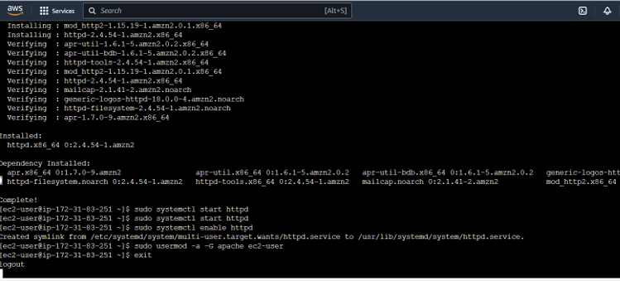

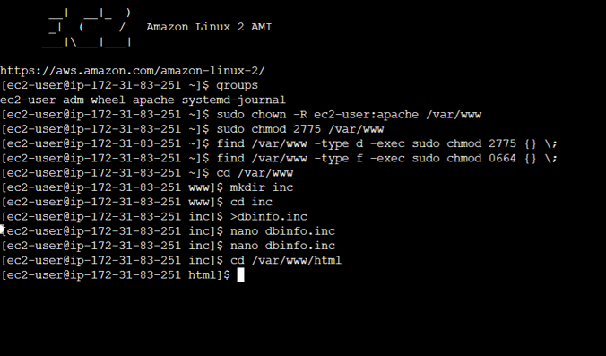

**Assignment 2: Working in Glue**

1. **Create IAM Role for Glue with AWSGlueServiceRole & S3FullAccess Permission**

* In IAM service create a new role
* Add Permissions for AWS Glue and S3 bucket

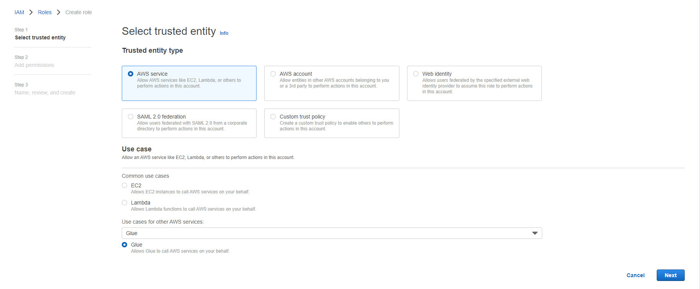

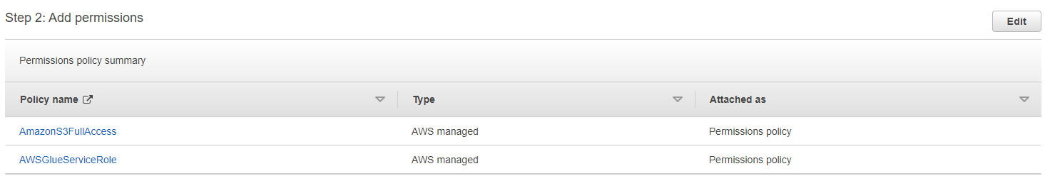

1. **Create Directory Structure in S3**

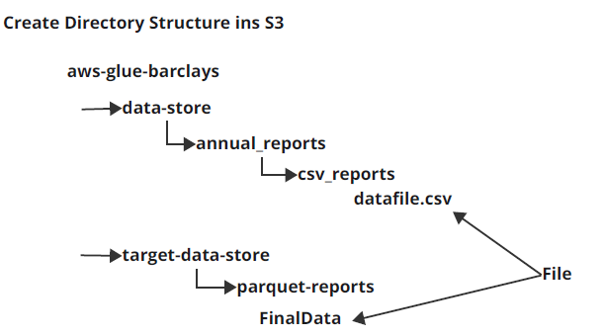

* In S3 bucket create the following folders in this hierarchy

1. Data-store

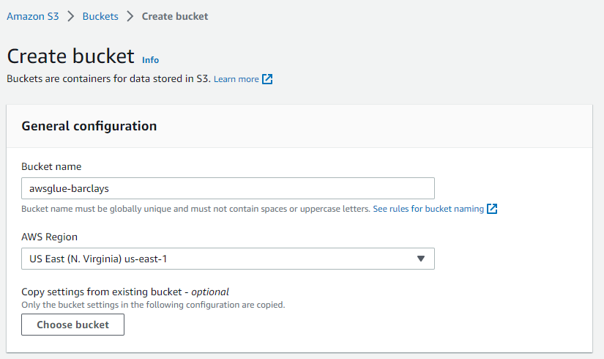

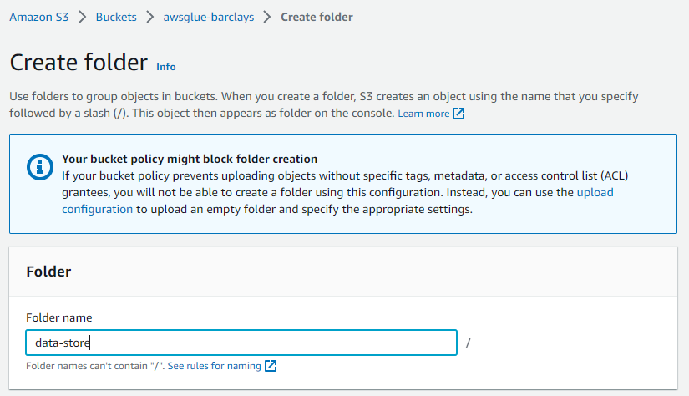

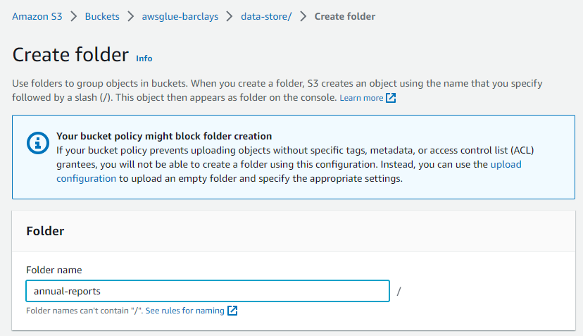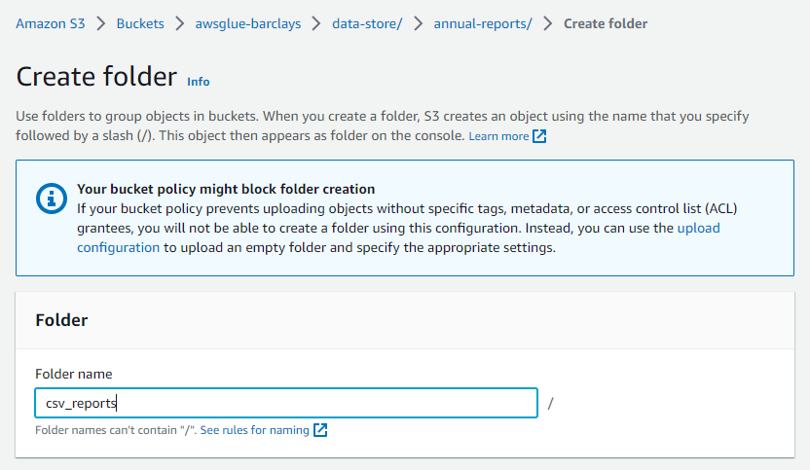

* In CSV Reports create a file and upload a CSV File

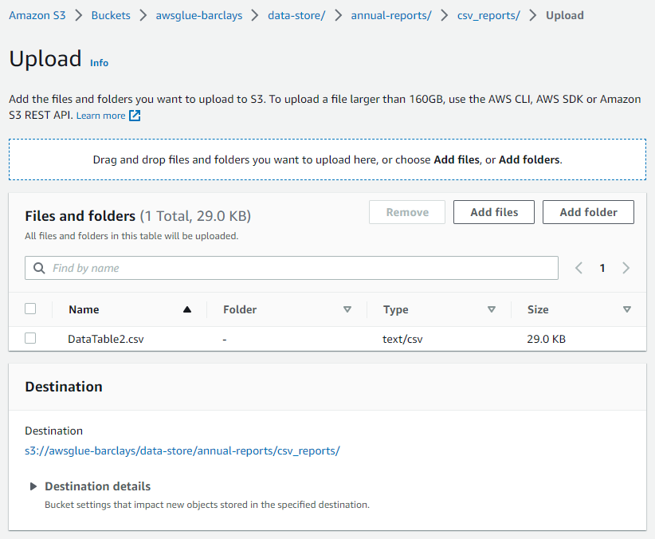

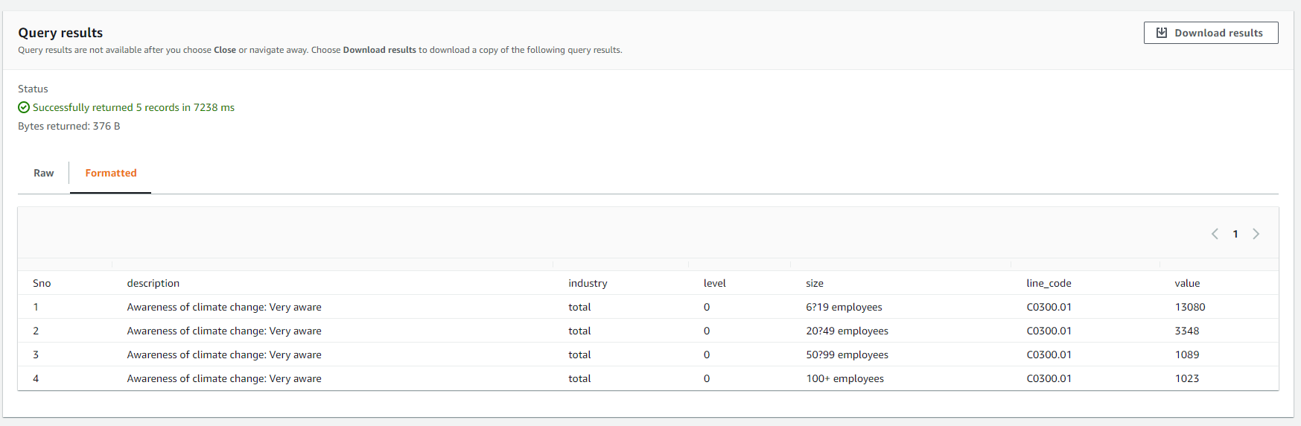

1. Target-Data-store

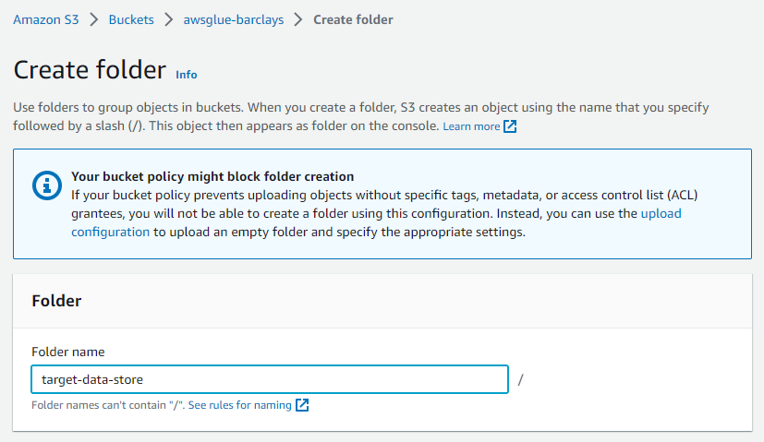

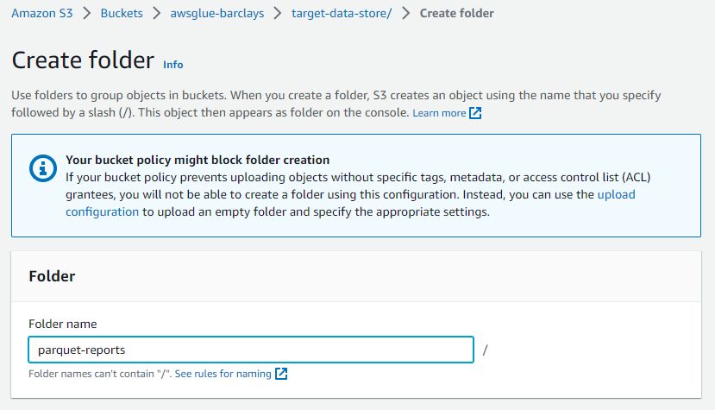

**3) Glue: Configure DataBase information**

* Create a Glue crawler service
* In this you must add the IAM role as well as the S3 bucket location

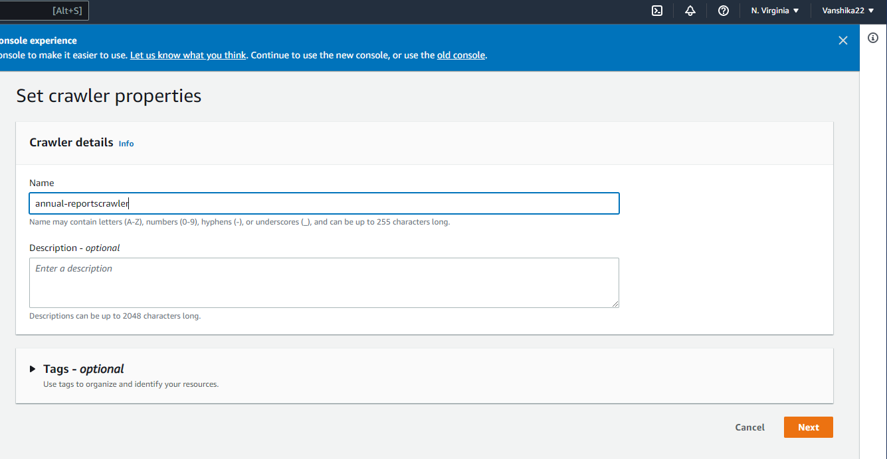

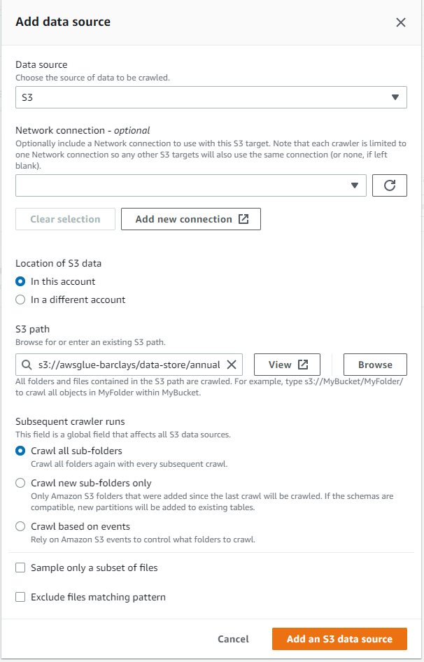

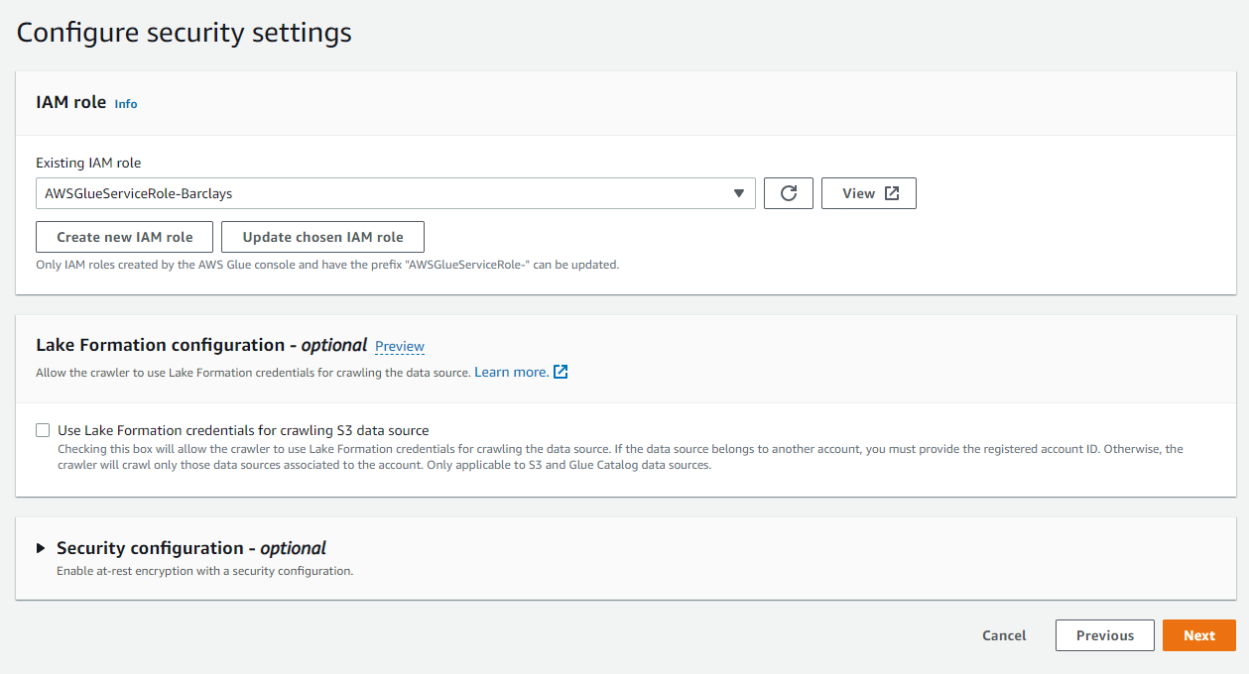

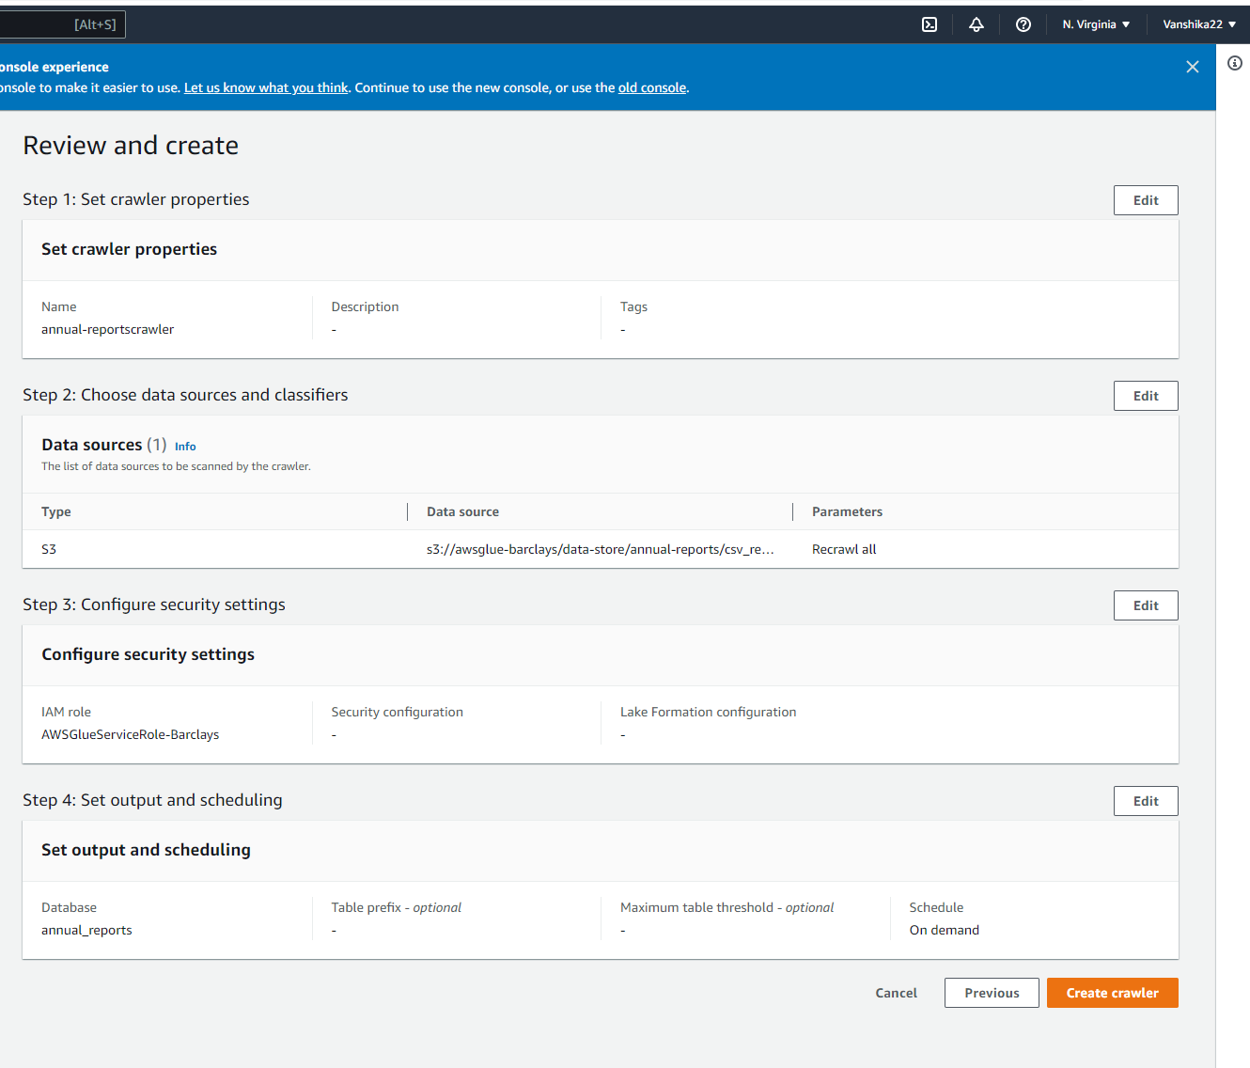

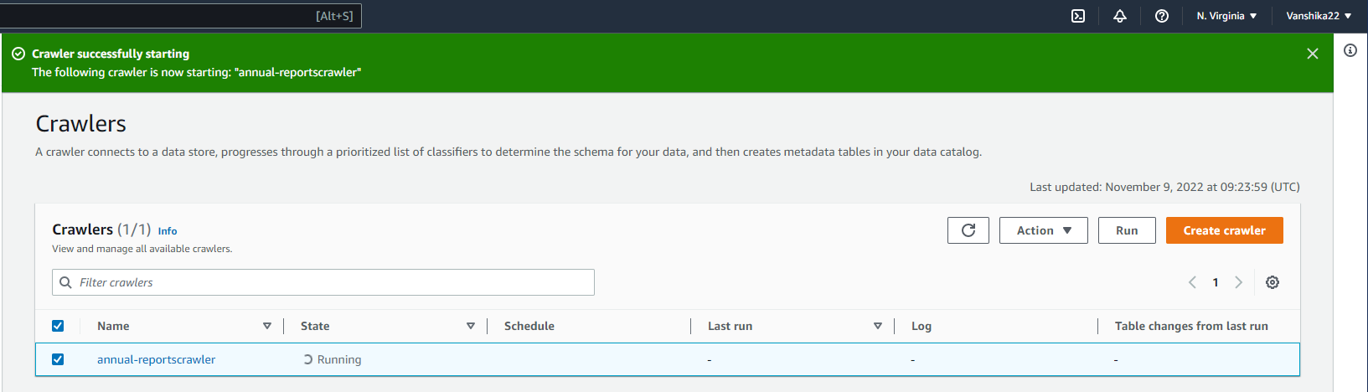

* Once the crawler is done Create a Job in AWS Glue Studio

